Details of referrer

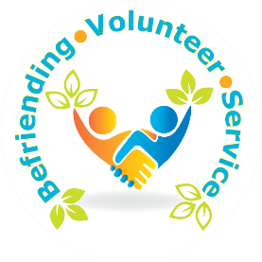
Full Name

Befriending Service Referral Form

(PLEASE USE CAPITALS)

Address
Phone Number
E-Mail
Job title/relationship to person you are referring

Consent obtained for referral Yes No
Please confirm the person being referred meets all of the eligibility criteria for the service

Lives alone in Hartlepool
Aged 65 years or older
Lonely and isolated (has contact with friends and family less than 3 times per week
Please confirm what the person is being referred for

Telephone befriending
Face to face befriending
Activities
Details of client

Name Address
Phone Number
Date of birth

Email

Preferred method of contact Phone Email
Letter
P.T.O ......

Any further information

(including communication needs and potential risk to staff and volunteers, if no risk, please state):

For More Information Contact:
befriending@clevelandfire.gov.uk
01429 872311

