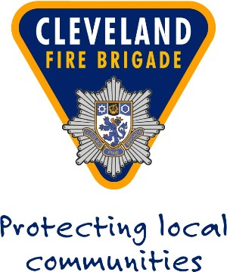
NOTES TO ASSIST YOU IN COMPLETING THE SUBJECT ACCESS FORM
- Please give as much detailed information in Section 2, this will assist us in locating the information held about you.
- Your application must be accompanied by at least two forms of identification. Between them, they should bear a combination of your name, address, signature and date of birth (e.g. Driving Licence, Passport, Medical Card, Birth/Adoption Certificate, Bank Statement, or Utility Bill). It is advised that you send photocopies of original documents – Cleveland Fire Brigade cannot be held accountable for original documents lost in the post. Photocopies must be certified by a Police Officer, Justice of the Peace, Solicitor, or person of similar standing.
- List any previous addresses that you have lived at in the last 3 years.
- There is no fee for a subject access request.
- The documents you supply as identification documents will be forwarded to your home address within approximately 5 days.
- If you are applying on behalf of someone else you must also enclose a signed letter from that person authorising you to act on their behalf.
- Forward the completed form with the required documentation to the address shown below.
- We will respond to your request within 30 days once in receipt of your application and Identification.
- These notes are only a guide. The law is set out in the General Data Protection Regulation.

If you require any further information or assistance please contact:
Data Protection Officer, ICT Department, Cleveland Fire Brigade, Training & Administration Hub, Endeavour House, Queens Meadow Business Park, Stockton Road, Hartlepool, TS25 5TH
phone: 01429 872311 or by email on: info@clevelandfire.gov.uk

