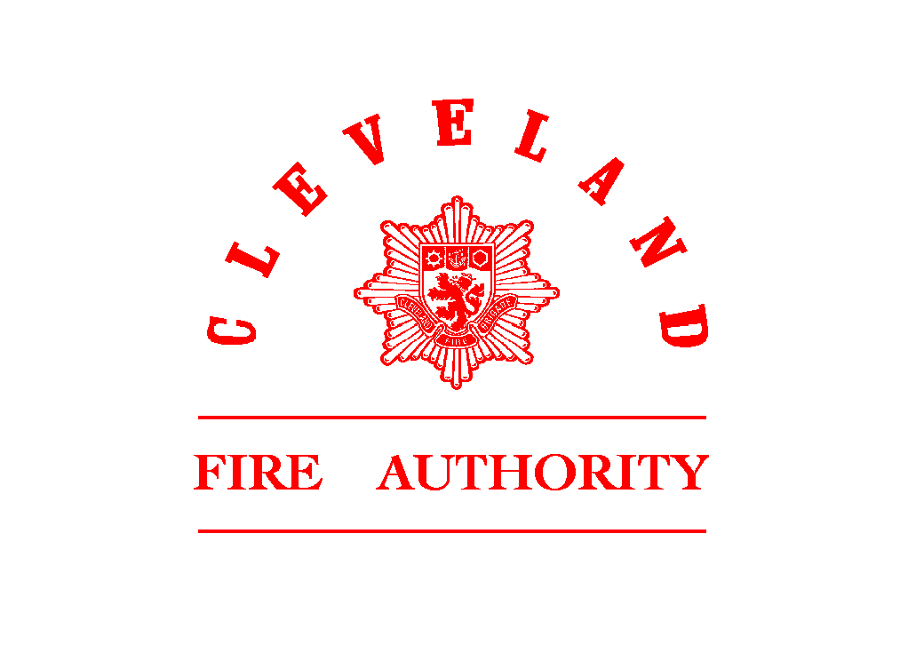
L OCAL PENSION BOARD
FIREFIGHTER PENSION SCHEMES

FULL PRIVACY NOTICE

This notice is for members [and beneficiaries] of the Firefighters’ Pension Scheme 1992 Order, The Firefighter Pension Scheme (England) Order 2006, the Firefighter Compensation Scheme (England) Order 2006, the Firefighter Pension Scheme 2015 and the Firefighters’ Pension Scheme Regulations (the "Scheme"). It has been prepared by Cleveland Fire Authority (the "Fire Authority", or "we") in its capacity as the manager of the Scheme (the "Scheme Manager") as delegated to the Chief Fire Officer).

This privacy notice is also provided at the following link:
www.clevelandfire.gov.uk

Why we are providing this notice to you
As Scheme Manager we hold certain information about you ("personal data") which we use to administer the Scheme and to pay benefits from it. This notice is designed to give you information about the data we hold about you, how we use it, your rights in relation to it and the safeguards that are in place to protect it.

The technical bit
The Fire Authority holds personal data about you in its capacity as data controller for the proper handling of all matters relating to the Scheme, including its administration and management. This includes the need to process your data to contact you, to calculate, secure and pay your benefits, for statistical and financial modelling and for reference purposes (for example, when we assess how much money is needed to provide members' benefits and to inform the Home Office of any additional funding requirements), and to manage liabilities and administer the Scheme generally. Further information about how we use your personal data is provided below.
The legal basis for our use of your personal data will generally be one or more of the following:
- we need to process your personal data to satisfy our legal obligations as Scheme Manager; and
- we need to process your personal data to carry out a task in the public interest or in the exercise of official authority in our capacity as a public body; and
- we need to process your personal data for the legitimate interests of administering and managing the Scheme and liabilities under it, calculating, securing and paying benefits and performing our obligations and exercising any rights, duties and discretions the Scheme Manager has in relation to the Scheme; and
- because we need to process your personal data to meet our contractual obligations to you in relation to the Scheme or to take steps, at your request, before entering into a contract.

What personal data we hold, and how we obtain it
The types of personal data we hold and process about you can include:
- Contact details, including name, address, telephone numbers and email address.
- Identifying details, including date of birth, national insurance number and employee and membership numbers.
- Information that is used to calculate and assess eligibility for benefits, for example, length of service or membership and salary information.
- Financial information relevant to the calculation or payment of benefits, for example, bank account and tax details.
- Information about your family, dependents or personal circumstances, for example, marital status and information relevant to the distribution and allocation of benefits payable on death.
- Information about your health, for example, to assess eligibility for benefits payable on ill health, or where your health is relevant to a claim for benefits following the death of a member of the Scheme.
- Information about a criminal conviction where this may result in pension forfeiture.
We obtain some of this personal data directly from you. We may also obtain data (for example, salary information) from your current or past employer(s), from a member of the Scheme (where you are or could be a beneficiary of the Scheme as a consequence of that person's membership of the Scheme) and from a variety of other sources including public databases (such as the Register of Births, Deaths and Marriages), our advisers and government or regulatory bodies, including those in the list of organisations that we may share your personal data with set out below.
Where we obtain information concerning certain "special categories" of particularly sensitive data, such as health information, extra protections apply under the data protection legislation. We will only process your personal data falling within one of the special categories with your consent, unless we can lawfully process this data for another reason permitted by that legislation. You have the right to withdraw your consent to the processing at any time by notifying the Fire Authority in writing. However, if you do not give consent, or subsequently withdraw it, the Fire Authority may not be able to process the relevant information to make decisions based on it, including decisions regarding the payment of your benefits.
Where you have provided us with personal data about other individuals, such as family members, dependants or potential beneficiaries under the Scheme, please ensure that those individuals are aware of the information contained within this notice.

How we will use your personal data
We will use this data to deal with all matters relating to the Scheme, including its administration and management. This can include the processing of your personal data for all or any of the following purposes:
- to contact you.
- to assess eligibility for, calculate and provide you (and, if you are a member of the Scheme, your beneficiaries upon your death) with benefits.
- to identify your potential or actual benefit options and, where relevant, implement those options.
- to allow alternative ways of delivering your benefits, for example, through the use of insurance products and transfers to or mergers with other pension arrangements.
- for statistical and financial modelling and reference purposes (for example, when we assess how much money is needed to provide members' benefits).
- to comply with our legal and regulatory obligations as Scheme Manager.
- to address queries from members and other beneficiaries and to respond to any actual or potential disputes concerning the Scheme.
- the management of the Scheme's liabilities.

Organisations that we may share your personal data with
From time to time we will share your personal data with advisers and service providers so that they can help us carry out our duties, rights and discretions in relation to the Scheme. Some of those organisations will simply process your personal data on our behalf and in accordance with our instructions. Other organisations will be responsible to you directly for their use of personal data that we share with them. They are referred to as data controllers and we have highlighted them in the table below. The data controllers may be obliged under the data protection legislation to provide you with additional information regarding the personal data that they hold about you and how and why they process that data. Further information may be provided to you in a separate notice or may be obtained from the advisers and service providers direct, for example, via their websites. In each case we will only do this to the extent that we consider the information is reasonably required for these purposes.

Where requested or if we consider that it is reasonably required, we may also provide your data to government bodies and dispute resolution and law enforcement organisations, including those listed above, the Pensions Regulator, the Pensions Ombudsman and Her Majesty's Revenue and Customs (HMRC). They may then use the data to carry out their statutory functions.
The organisations referred to in the paragraphs above may use the personal data to perform their functions in relation to the Scheme as well as for statistical and financial modelling (such as calculating expected average benefit costs and mortality rates) and planning, business administration and regulatory purposes. They may also pass the data to other third parties, to the extent they consider the information is reasonably required for a legitimate purpose.
In some cases recipients of your personal data may be outside the UK. This means your personal data may be transferred outside the European Economic Area ("EEA") to a jurisdiction that may not offer an equivalent level of protection as is required by EEA countries. If this occurs, we are obliged to verify that appropriate safeguards are implemented with a view to protecting your data in accordance with applicable laws. Please use the contact details below if you want more information about the safeguards that are currently in place.

How long we keep your personal data
We will only keep your personal data for as long as we need to in order to fulfil the purpose(s) for which it was collected and for so long afterwards as we consider may be required to deal with any questions or complaints that we may receive about our administration of the Scheme, unless we elect to retain your data for a longer period to comply with our legal and regulatory obligations.

In practice, this means that your personal data will be retained for such period as you (or any beneficiary who receives benefits after your death) are entitled to benefits from the Scheme and for a period of 15 years after those benefits stop being paid. For the same reason, your personal data may also need to be retained where you have received a transfer, or refund, from the Scheme in respect of your benefit entitlement.

Your rights
You have a right to access and obtain a copy of the personal data that the Fire Authority holds about you and to ask the Fire Authority to correct your personal data if there are any errors or it is out of date or incomplete. In certain circumstances you have the right to object to the processing of your personal data; for example you have the right to object to processing of your personal data which is based on the legitimate interests identified in the section above headed "The Technical Bit", or where the processing is for direct marketing purposes.

In some cases you may also have a right to ask the Fire Authority to restrict the processing of your personal data until any errors are corrected or to transfer or (in very limited circumstances) erase your personal data. You can obtain further information about these rights from the Information Commissioner's Office, Wycliffe House, Water Lane, Wilmslow, Cheshire, SK9 5AF; at: www.ico.org.uk or via its telephone helpline (0303 123 1113).
If you wish to exercise any of these rights or have any queries or concerns regarding the processing of your personal data, please contact The Fire Authority as indicated below. You also have the right to lodge a complaint in relation to this privacy notice or the Fire Authority's processing activities with the Information Commissioner's Office which you can do through the website above or their telephone helpline.
As explained in the section above headed "How we will use your personal data", one of the reasons we collect and hold your personal data is to administer your Scheme benefits. If you do not provide the information we request, or ask that the personal data we already hold is deleted or that the processing of the personal data be restricted, this may affect our ability to administer your benefits, including the payment of benefits from the Scheme. In some cases it could mean the Fire Authority is unable to put your pension into payment or has to stop your pension (if already in payment).

Updates
We may update this notice periodically. Where we do this we will inform members of the changes and the date on which the changes take effect.

Contacting us
Please contact the Administrator [XPS Administration on 01642 727777] or the Fire Authority [Human Resources on 01429 874020] for further information.

Data Protection Officer
You may also contact our data protection officer [who is the Head of ICT – 01429 874099 or 874040] for further information.

