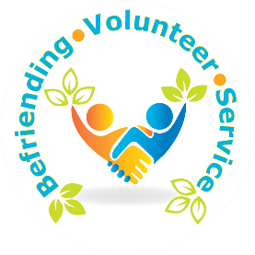

**Befriending Service**

**Later Life Club Referral Form**

Details of referrer

Full Name

(PLEASE USE CAPITALS)

Address

Phone Number

E-Mail

Job title/relationship to person you are referring

Consent obtained for referral  Yes  No Date of Referral……………………….

Please confirm the person being referred meets all of the eligibility criteria for the service

Lives alone in Redcar 

Aged 65 years or older

Fees lonely and isolated

Please confirm what the person is being referred for



Activities

Details of client

Name Address

Phone Number

Date of birth

Email

Preferred method of contact Phone Email

Letter

P.T.O ......

Any further information

(including communication needs and potential risk to staff and volunteers, if no risk, please state):



Please send to :

[laterlifeclub@clevelandfire.gov.uk](mailto:laterlifeclub@clevelandfire.gov.uk)

**01429 872311**